# CS 255 System Design Document Template

This template lays out all the different sections that you need to complete for Project Two. Each section has guidance to prompt your thinking. You will need to continually reference the interview transcript as you work to make sure that you are addressing your client’s needs. There is no required length for the final document. Instead the goal is to complete each section based on what your client’s needs are. Remove this note when you are finished, and replace all bracketed text with the relevant information.

## UML Diagrams

### UML Use Case Diagram

### UML Activity Diagrams

### UML Sequence Diagram

### UML Class Diagram

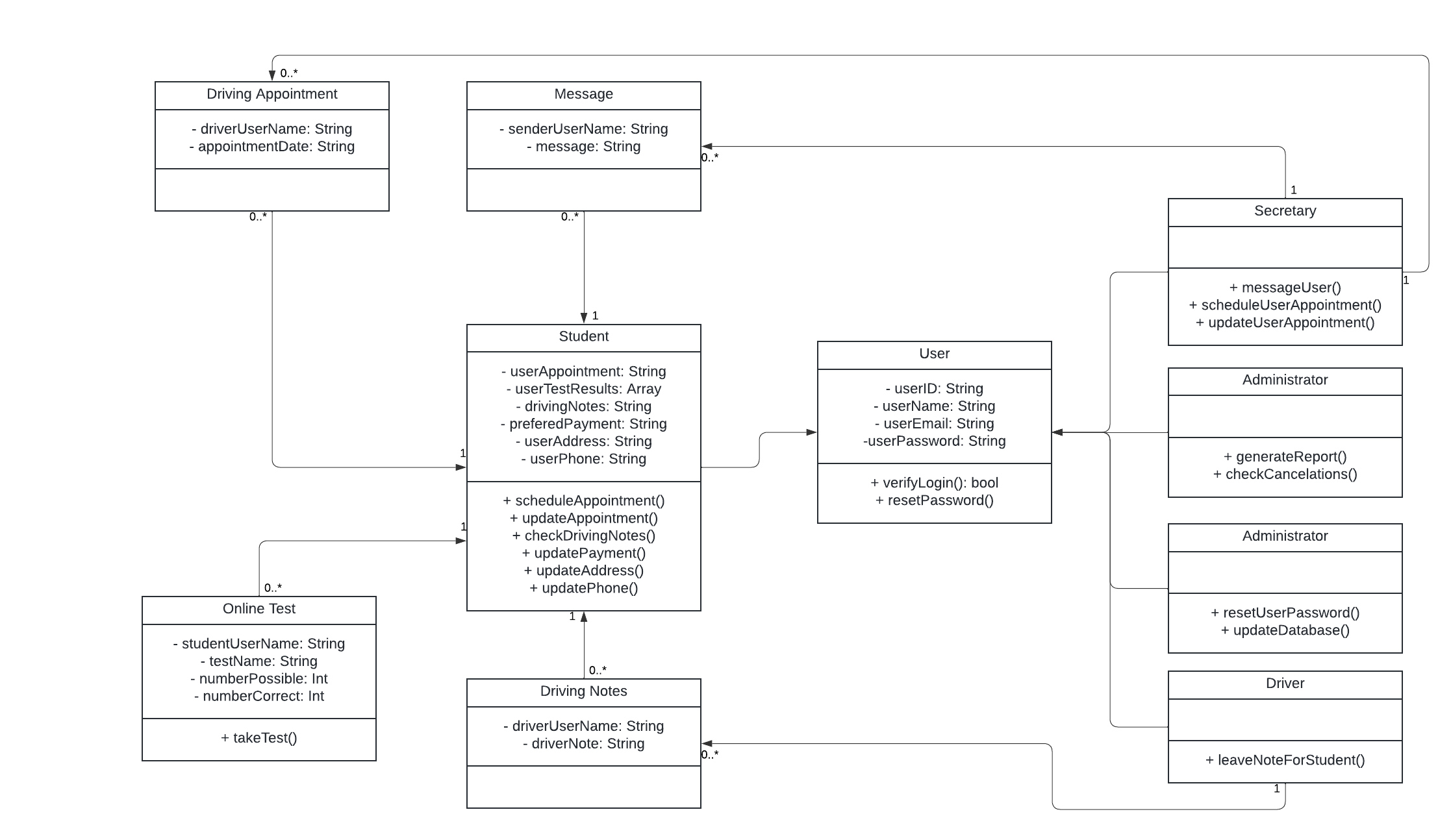

## Technical Requirements

This system is based around being a cloud based mobile application. The hardware needed will primarily be a cloud-based server that allows for IT, Ian, to connect to the system as needed to confirm the database is working correctly, and to reset user passwords as needed. There will need to be a way of updating the system automatically either through an API, or a data packet that is sent from the DMV to ensure that the system’s information is kept up to date with the latest DMV rules and regulations. This system will ideally run autonomously and need little to no ongoing supervision or additional code rewrites. The system should update itself to allow for clearing the cache and potential lag within the system.